for loop in C

The **for loop in C language** is used to iterate the statements or a part of the program several times. It is frequently used to traverse the data structures like the array and linked list.

Syntax of for loop in C

The syntax of for loop in c language is given below:

1. **for**(Expression 1; Expression 2; Expression 3){
2. //code to be executed
3. }

Flowchart of for loop in C

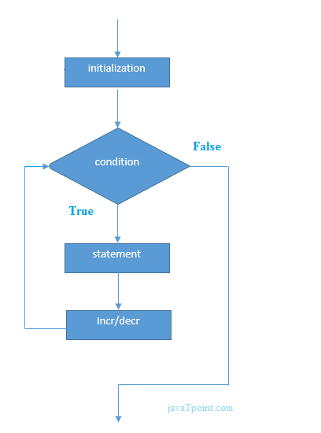

C for loop Examples

Let's see the simple program of for loop that prints table of 1.

1. #include<stdio.h>
2. **int** main(){
3. **int** i=0;
4. **for**(i=1;i<=10;i++){
5. printf("%d \n",i);
6. }
7. **return** 0;
8. }

**Output**

1

2

3

4

5

6

7

8

9

10

C Program: Print table for the given number using C for loop

1. #include<stdio.h>
2. **int** main(){
3. **int** i=1,number=0;
4. printf("Enter a number: ");
5. scanf("%d",&number);
6. **for**(i=1;i<=10;i++){
7. printf("%d \n",(number*i));
8. }
9. **return** 0;
10. }

**Output**

Enter a number: 2

2

4

6

8

10

12

14

16

18

20

Enter a number: 1000

1000

2000

3000

4000

5000

6000

7000

8000

9000

10000

Properties of Expression 1

* The expression represents the initialization of the loop variable.
* We can initialize more than one variable in Expression 1.
* Expression 1 is optional.
* In C, we can not declare the variables in Expression 1. However, It can be an exception in some compilers.

**Example 1**

1. #include <stdio.h>
2. **int** main()
3. {
4. **int** a,b,c;
5. **for**(a=0,b=12,c=23;a<2;a++)
6. {
7. printf("%d ",a+b+c);
8. }
9. }

**Output**

35 36

**Example 2**

1. #include <stdio.h>
2. **int** main()
3. {
4. **int** i=1;
5. **for**(;i<5;i++)
6. {
7. printf("%d ",i);
8. }
9. }

**Output**

1 2 3 4

Properties of Expression 2

* Expression 2 is a conditional expression. It checks for a specific condition to be satisfied. If it is not, the loop is terminated.
* Expression 2 can have more than one condition. However, the loop will iterate until the last condition becomes false. Other conditions will be treated as statements.
* Expression 2 is optional.
* Expression 2 can perform the task of expression 1 and expression 3. That is, we can initialize the variable as well as update the loop variable in expression 2 itself.
* We can pass zero or non-zero value in expression 2. However, in C, any non-zero value is true, and zero is false by default.

**Example 1**

1. #include <stdio.h>
2. **int** main()
3. {
4. **int** i;
5. **for**(i=0;i<=4;i++)
6. {
7. printf("%d ",i);
8. }
9. }

**output**

0 1 2 3 4

**Example 2**

1. #include <stdio.h>
2. **int** main()
3. {
4. **int** i,j,k;
5. **for**(i=0,j=0,k=0;i<4,k<8,j<10;i++)
6. {
7. printf("%d %d %d\n",i,j,k);
8. j+=2;
9. k+=3;
10. }
11. }

**Output**

0 0 0

1 2 3

2 4 6

3 6 9

4 8 12

**Example 3**

1. #include <stdio.h>
2. **int** main()
3. {
4. **int** i;
5. **for**(i=0;;i++)
6. {
7. printf("%d",i);
8. }
9. }

**Output**

infinite loop

Properties of Expression 3

* Expression 3 is used to update the loop variable.
* We can update more than one variable at the same time.
* Expression 3 is optional.

**Example 1**

1. #include<stdio.h>
2. **void** main ()
3. {
4. **int** i=0,j=2;
5. **for**(i = 0;i<5;i++,j=j+2)
6. {
7. printf("%d %d\n",i,j);
8. }
9. }

**Output**

0 2

1 4

2 6

3 8

4 10

Loop body

The braces {} are used to define the scope of the loop. However, if the loop contains only one statement, then we don't need to use braces. A loop without a body is possible. The braces work as a block separator, i.e., the value variable declared inside for loop is valid only for that block and not outside. Consider the following example.

1. #include<stdio.h>
2. **void** main ()
3. {
4. **int** i;
5. **for**(i=0;i<10;i++)
6. {
7. **int** i = 20;
8. printf("%d ",i);
9. }
10. }

**Output**

20 20 20 20 20 20 20 20 20 20

Infinitive for loop in C

To make a for loop infinite, we need not give any expression in the syntax. Instead of that, we need to provide two semicolons to validate the syntax of the for loop. This will work as an infinite for loop.

1. #include<stdio.h>
2. **void** main ()
3. {
4. **for**(;;)
5. {
6. printf("welcome to javatpoint");
7. }
8. }

If you run this program, you will see above statement infinite times.